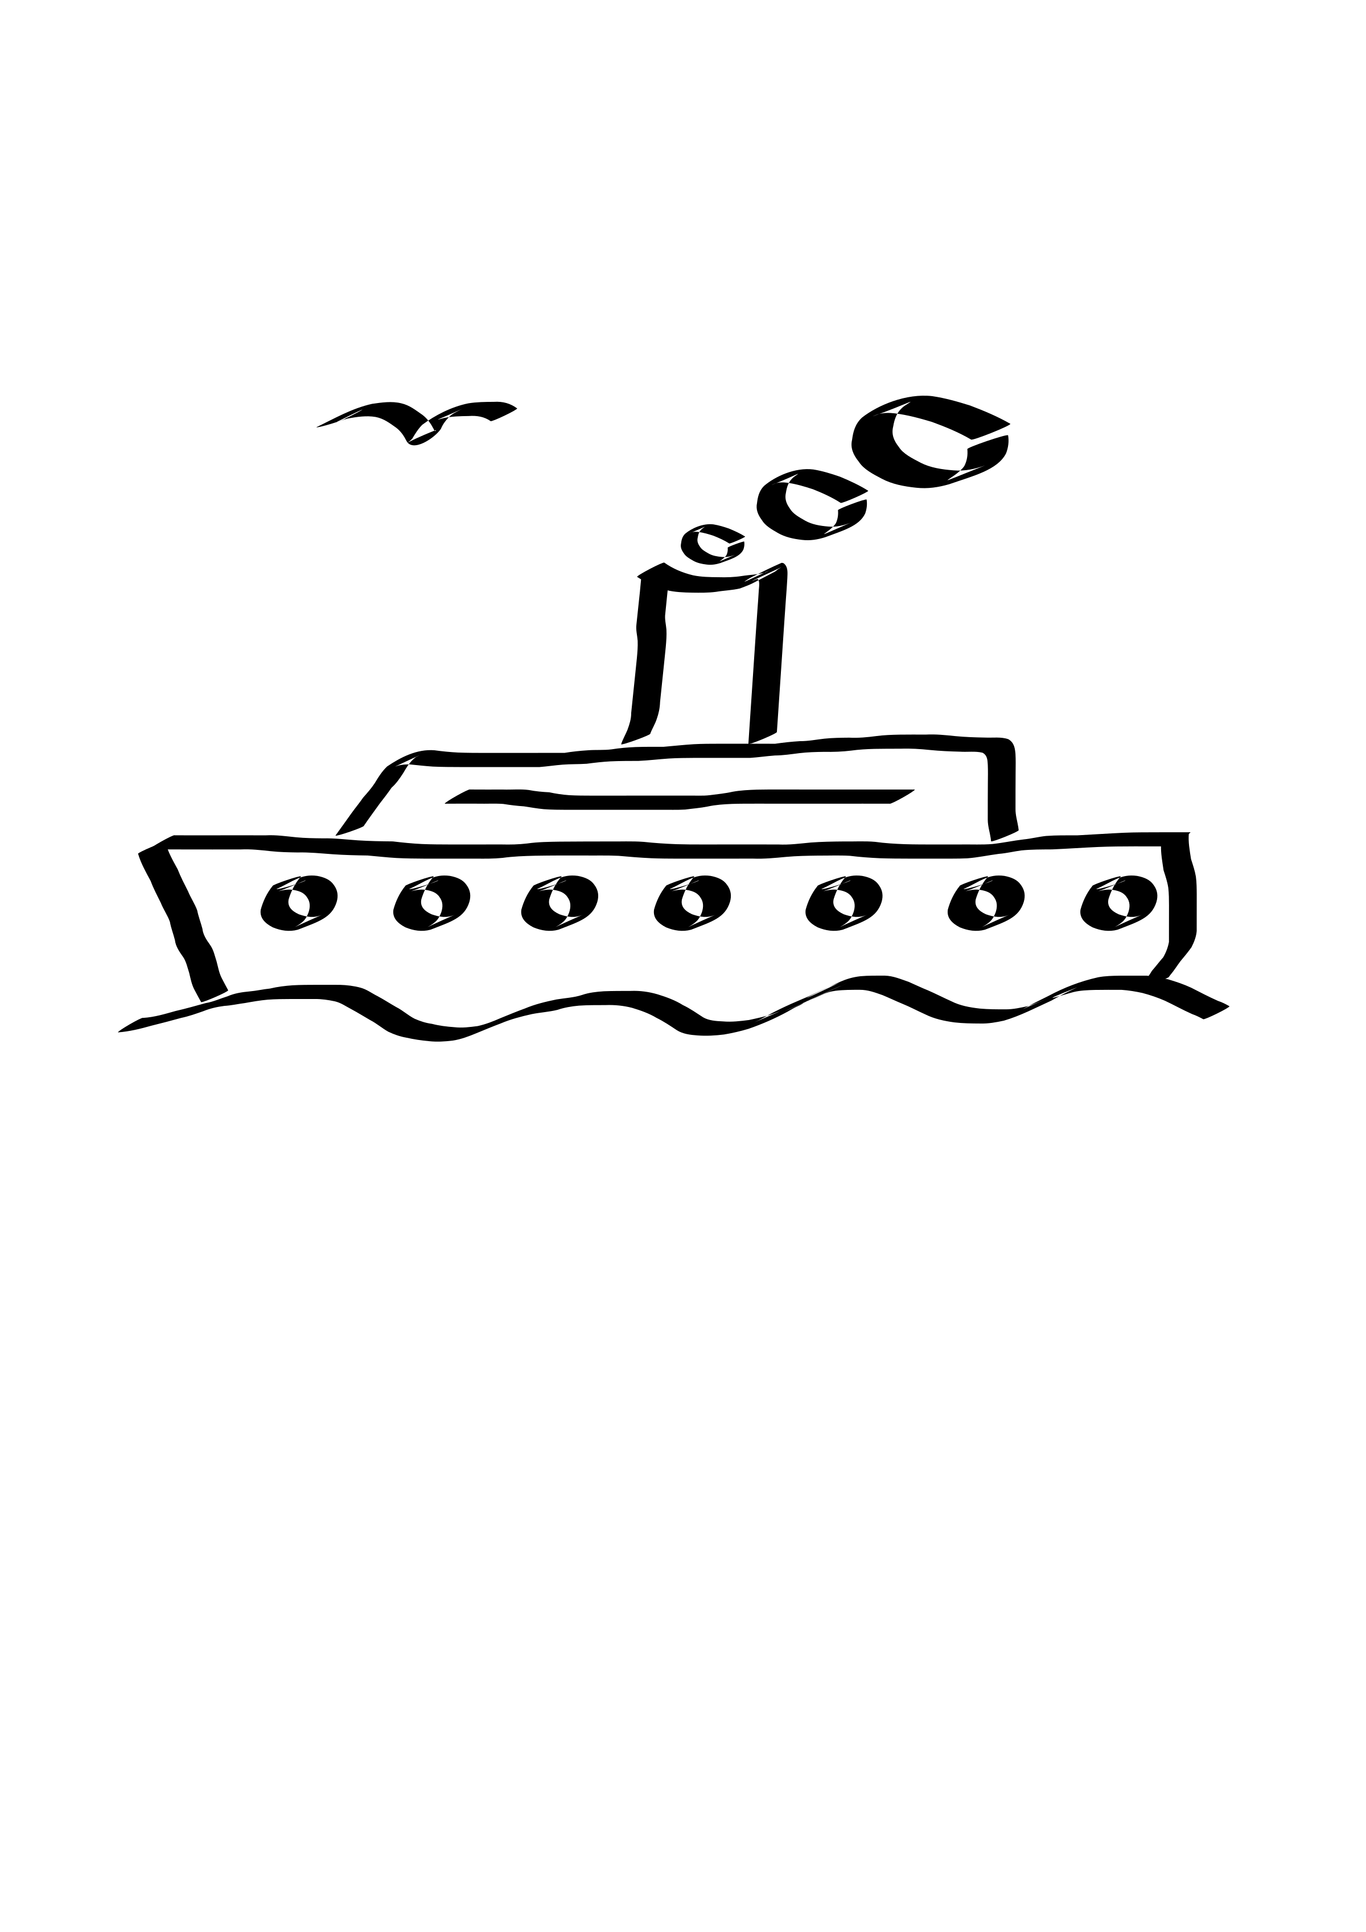

APPLICATION
(Please fill out both pages completely – using one application per person)

PRICE PER PERSON: $3679.00 inclusive for LAND portion and AIR (based upon double occupancy)
***NOTE: cost for group airline travel is estimated to be approximately $1200 and is subject to change until July 2019 when postings and reservations become available. Flights may be requested from any US city – participants will pay only the difference.

A $700 deposit made payable to: Gifts From Above, is due: beginning July 1, 2018.
A SECOND INSTALLMENT IN THE AMOUNT OF $800 is due: April 1, 2019
Final payments are due: Jan 1, 2020. (sorry, we do not accept credit cards)

OUR REFUND POLICY – PLEASE NOTE: Travel insurance is highly recommended.
Gifts From Above Inspirational Travel will issue a full refund of all deposits within a 30 day period of application. Due to supplier regulations, a $350 administrative fee will be deducted from all refunds requested after 30 days.
Upon receipt of second installment, we will purchase group airline seats. Airline seats are non refundable/ non transferable and are not exchangeable. Once group airline ticketing is completed, cancellations will not receive a refund of the deposit or second installment of total cruise/tour cost.
60 days prior to departure only a 25% refund of the total cost will apply.
Cancellations made between 59 and 30 days prior to travel will receive only a 10% refund of total cost.
Cancellations made 29 days or less before travel date are ineligible for any refunds.
– ANY REQUESTS FOR CANCELLATIONS MUST BE MADE IN WRITING TO GIFTS FROM ABOVE. THE POST MARK ON THE ENVELOPE WILL SERVE AS DATE OF OFFICIAL NOTICE OF INTENT TO CANCEL.
Please visit our web site, giftsfromabove.info. It features detailed itinerary information; travel insurance suggestions; helpful packing hints; “what to know before you go”.

Kindly mail all applications, and/or cancellation notices to:
ROBERTA KLEIN
GIFTS FROM ABOVE
3130 MEMORIAL HWY, SUITE 100-102
DALLAS, PA 18612
Phone: 570.575.1710 // Web site : giftsfromabove.info // Fax: 570.675.3225 // E-mail: ark2@epix.net

YOUR FULL NAME: ____________________________________________________________________________
(PRINTED exactly as it appears on your passport)
YOUR DATE OF BIRTH:___________ GENDER:____ YOUR PASSPORT #:_______________________
(Please make a photocopy of the photo page of your passport and submit it along with this application.)
STREET ADDRESS:____________________________________________________________________
CITY & STATE:_______________________________ ZIPCODE:_________
MOBILE/ CELL PHONE #:_________________________ E-mail:______________________

HOTEL AND CRUISE SHIP STATEROOM ACCOMODATIONS:
* Please book me in an Inside stateroom on Deck 3 (no extra charge):_______
* I would like to upgrade my stateroom to a 7th Deck midship room with window ($420 per person):_______
* I will be rooming with:___________________________________
* Will you need a roommate? Yes____ No_____ (if none is available you will need a single room.)
* I prefer a single room:________ ($SINGLE ROOM SUPPLEMENT: 30% FOR CRUISE(inside and outside staterooms)
PLEASE NOTE – WE WILL WORK TO MATCH ROOMMATES FOR THOSE WHO REQUEST US TO DO SO; HOWEVER GIFTS FROM ABOVE WILL NOT BE RESPONSIBLE FOR ANY PROBLEMS OR ADDED COSTS WHICH RESULT FROM ROOMMATES PROVING INCOMPATIBLE. SHOULD A PRIVATE STATEROOM BE NECESSARY, IT WILL BE THE INDIVIDUAL’S RESPONSIBILITY. (Please carefully check your travel insurance policy at the time of purchase for coverage in that regard).
GENERAL INFORMATION:
Will this be your first trip to the Eastern Mediterranean? Yes____ No ____
Do you require a special diet meal for your flight or cruise? Yes____ No____
If so, what type of diet?__________________________________________________
Do you have any special travel needs or handicaps?__________________________________
If so, will you require a special seat assignment for your flight?__________________________
NAME AND ADDRESS OF EMERGENCY CONTACT PERSON:
_________________________________________________________________________________
PHONE#__________________ RELATIONSHIP:___________________________________
YOUR PHONE OR EMERGENCY CONTACT E-MAIL WHILE ON-TOUR:
___________________________________________________________________________________
PLEASE NOTE -- AIRLINE TICKETS AND SEAT ASSIGNMENTS - We negotiate special rates with major carriers and air arrangements are subject to certain restrictions on change/or cancellation, eligibility and seat assignments. Group seating policy is different for each airline. Gifts From Above is not in control of seat assignments. Seats are subject to airline discretion and may change without notice. We do everything possible to confirm seats whenever available. Some airlines and/or fare types do not allow for pre-seating and require this be done at airport check-in only. Even when seats are originally pre-assigned, they are not guaranteed and can be modified by the airline due to equipment changes. Bulkhead and exit row seats cannot be requested and pre-assign ahead of time. Bulkhead seats are given to the passengers traveling with infants and for those with disability. Exit row seats are held for assignment at airport check in only, as passengers wishing to sit in these seats must be physically capable of carrying out the associated responsibilities. The airline agent must see a passenger’s physical condition before assigning them an exit row seat. On most routes, these seats can be purchased for a fee on arrival at the airport.
At the time of booking flights we will update all travelers on seating regulations.
Gifts From Above is not responsible for flights that are occasionally overbooked, delayed or cancelled by the airlines. All fares and schedules are subject to change without notice.

